**2021-2022-2**

**Mid-Term Exam Paper**

**for Reading and Writing Course on EAP**

**Class** **_________________Name _________________Student No. _________________**

***Directions:*** *You are required to write a summary about the following passage. You should write about 200 words.*

**The Metaverse in Medicine**

Dawei Yang, Jian Zhou

Department of Pulmonary and Critical Care Medicine,

Zhongshan Hospital Fudan University, Shanghai, China

(adapted from *Clinical eHealth*, published on 4 February 2022)

Since 2021, the concept of the metaverse has been widely discussed. It refers to the internet accessed via virtual reality (VR)and augmented reality (AR) glasses, and is considered to be the next-generation mobile computing platform that will be widely used in the future. Recently, the Chinese medical experts proposed the metaverse in medicine, and suggested naming 2022 as the Year of the Metaverse in Medicine.

The Metaverse in Medicine can be defined as the medical Internet of Things (MIoT) facilitated using AR and VR glasses. So far the researchers have conducted extensive research on the MIoT, which serves as the foundation for establishing the Metaverse in Medicine. For example, they focused on the research and development of the BRM all-in-one machine, which can be seen as the prototype of the Metaverse in Medicine. More recently, they have initiated a related study to further explore how to implement the Metaverse in Medicine by applying holographic construction and emulation, and virtuality reality integration and interconnection. In order to put it into better practice, they suggest to broaden the concept by adding comprehensive perception to the holographic construction, adding intelligent processing to the holographic emulation, adding quality control to the virtuality-reality integration, and adding human–computer integration to the virtuality-reality interconnection, thus realizing ‘‘simplification of complex problems, digitalization of simple problems, programming of digital problems, and systematization of programming problems”. This approach can overcome the obstacle that internet-based healthcare and telemedicine platforms hardly play an active role in county hospitals, especially those in rural villages and towns. Moreover, it will facilitate graded diagnosis and treatment, and contribute to transforming the current handicraft workshop model, which varies between doctors and hospitals with uneven levels, into a modern assembly-line model that meets national and even international standards.

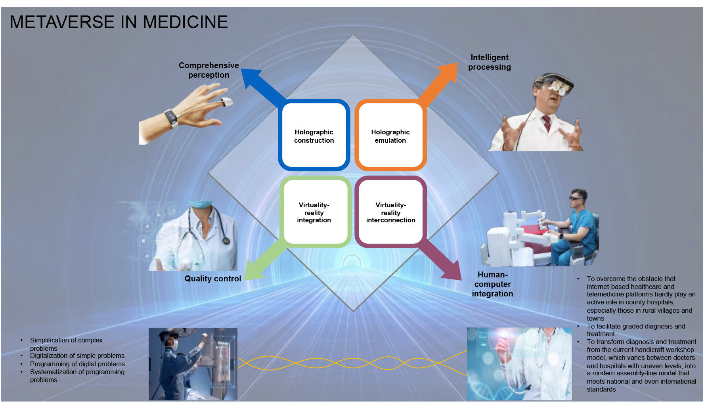

(Flowchart of implementing the Metaverse in Medicine by applying holographic construction and emulation, and virtuality-reality integration and interconnection.)

Holographic construction, also known as multi-dimensional or stereoscopic information, refers to a model incorporating all the information of a certain system, which has been collected and compiled from multiple channels, perspectives, and positions. The data in the system should include not only specific information on the working status of each device, data transmission, and system interaction, but also data on the factors that influence the operation of the system, such as the natural and social environment in which the system is located. At present, VR home inspection and shop inspection are applications in the holographic construction. Holographic emulation is a new feature that vastly reduces iteration time when developing holographic applications in Unity. Studies have shown that developers creating applications for Microsoft HoloLens will immediately benefit from being able to prototype, debug, and iterate design directly from the Unity Editor without getting bogged down by long build and deploy times. Although the current research is not applied to medicine, the preliminary study suggests that holographic emulation is a promising technique for the medical field because it can address the issue of how to enable experts to provide services at all times and in all settings, which cannot be solved by the MIoT.

How can the experts fully apply holographic construction and holographic emulation in medical practice? The first step is to understand the pathological, pathophysiological, or biochemical changes caused by different diseases, in order to strictly implement P4 medicine (predictive, preventive, personalized, and participatory). To solve practical problems, they suggest to introduce the concept of comprehensive perception in the holographic construction and emulation of the metaverse, since current studies have confirmed that it can meet the requirements of the Metaverse in Medicine. A solid technological foundation has already been laid in medicine, including the use of a variety of sensors applying photosensitive, gas sensitive, force sensitive, sound sensitive, and radiation sensitive components, biochemical examinations to test liver and kidney function, electrocardiography (ECG), ultrasound and computed tomography (CT). These technologies help monitor the physiological, pathophysiological, and biochemical changes in the body at all times and in all settings (or partly), and create a complete infographic of the condition of health, sub-health, or disease. Consequently, doctors and patients can enter the metaverse with their own digital twin, and practice metaverse medicine through virtuality-reality interconnection. Only when the metaverse creates an immersive experience, in which people cannot distinguish the virtual world from the real one, will it attract the participation of patients and doctors.

The Metaverse in Medicine may also be applied to improve the efficiency of education and training, since it can address the issues that the cloud experts are not available to participate in science popularization and professional lectures, or to provide guidance for the terminal doctors on diagnosis and treatment as if they were present at all times and in all settings. For instance, the expert used the BRM all-in-one machine adopting holographic emulation technology to show students the mechanism of cigarette smoking-induced lung cancer. This pioneering pedagogical practice produced sensational effects because the students observed in an immersive way the alveolar damage caused by smoking and its relationship with the onset of lung cancer. Furthermore, students can also be trained to quickly master various therapeutic techniques as if they were present in clinical practice, such as magnetic navigation, a difficult technique to apply in surgeries with respiratory endoscopy. If holographic emulation is used in teaching and clinical practice, it will undoubtedly help to achieve better results with less effort.

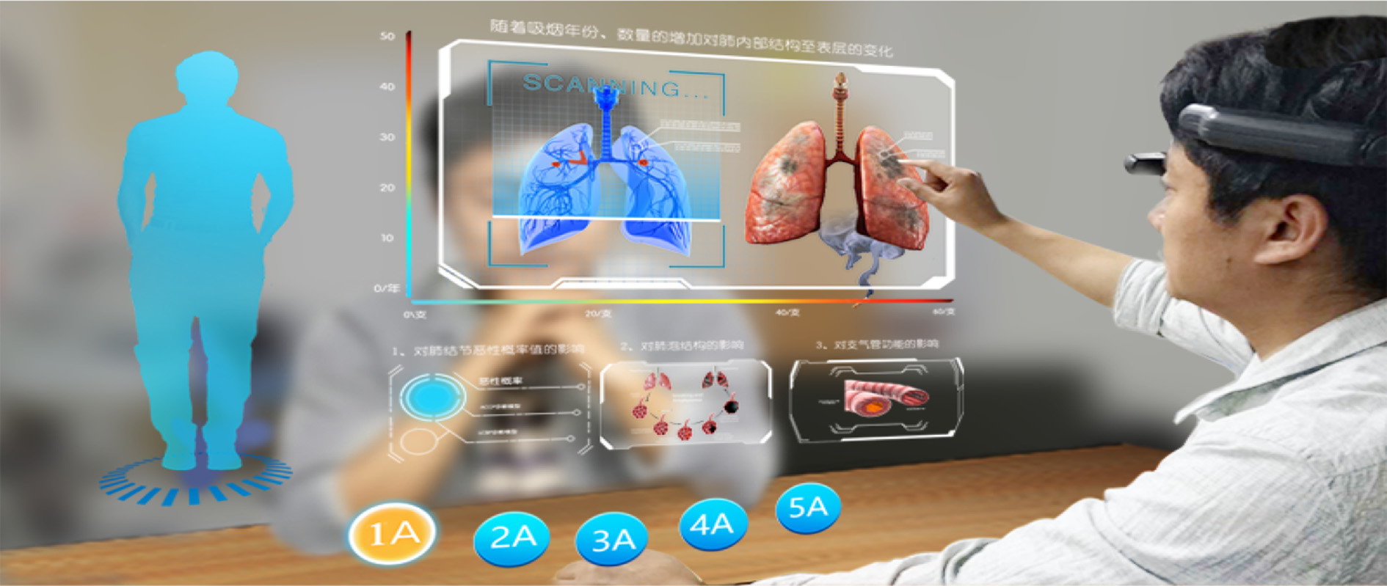

(The BRM all-in-one machine adopting holographic emulation technology vividly demonstrates the mechanism of cigarette smoking-induced lung cancer)

The research and practice of the Metaverse in Medicine can be difficult, since the body structure, etiology, pathological and pathophysiological changes, as well as the pharmacodynamics in different patients are extremely complicated. However, based on the successful cases of applying the concept of the Metaverse in Medicine in the diagnosis and treatment of pulmonary nodules, the experts estimate that solutions and principles can be found through careful classification of the diseases and extension of the research on applying the metaverse in the diagnosis and treatment of diseases to different categories.

After working out a solution that combines comprehensive perception with holographic construction, the information required for the holographic construction will be transmitted to the ‘‘Metaverse in Medicine Cloud”, in preparation for the next step, holographic emulation plus intelligent processing, and eventually transforming the real world through the virtual one. Once all these issues are settled, the emulation technology can be leveraged in the virtual world to seek optimal solutions for the problems in reality, and map it to the real world through virtuality-reality integration, so that the virtual and the real experts provide guidance for medical practice in the real world.